

Table of Contents

Virtual Medical Home

1. Introduction
   1. Methodology  3
   2. Purpose  4
   3. Scope  4

|  |  |  |
| --- | --- | --- |
| 1.4 | Definitions, Acronyms and Abbreviations | 5 |
| 1.5 | Tools Used | 6 |
| 1.6 | References | 7 |
| 1.7 | Technologies to be used | 7 |
| 1.8 | Overview | 7 |
| 2. Overall Description | |  |
| 2.1 | Product Perspective | 8 |
| 2.2 | Software Interface | 8 |
| 2.3 | Hardware Interface | 9 |
| 2.4 | Communication Interface | 10 |
| 2.5 | Constraints | 10 |
| 2.6 ER Diagram | | 10 |
| 2.7 Use-Case Model Survey | | 11 |
| 2.8 | Architecture Design | 12 |
| 2.9 Database Design | | 13 |
| 3. Specific Requirements | |  |
| 3.1 | Use-Case Reports | 14 |
| 3.2 | Activity Diagrams | 18 |
| 3.3 Sequence Diagrams | | 28 |
| 4. Supporting Information | |  |
| 4.1 | Index | 34 |



**1. Introduction**

**1.1 Methodology**

Rational Unified Process



*2009* *Page 2*

Virtual Medical Home

The Rational Unified Process brings together elements from all of the generic process models, sup-ports iteration and illustrates good practice in specification and design. The RUP is normally de-scribed from three perspectives:

A ***dynamic perspective*** that shows the phases of the model over time.

A ***static perspective*** that shows the process activities that are enacted.

A ***practice perspective*** that suggests good practices to be used during the process.

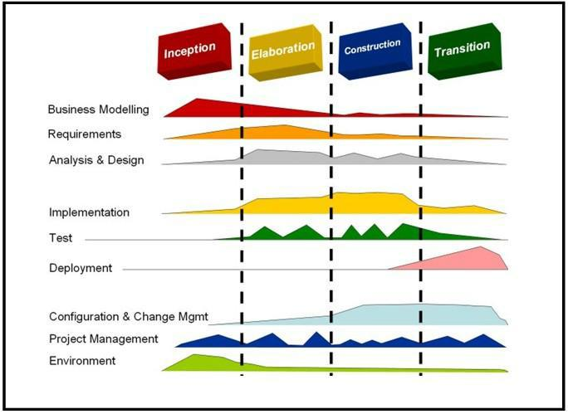

Fig 1.1:Phases of RUP

The different phases in RUP are

**Inception**

The goal of the inception phase is to establish a business case for the system. Identifying all external entities that will interact with the system and defining these interaction. This information is used to assess the contribution of system to business.

**Elaboration**

The goals of the elaboration phase are to develop an understanding of the problem domain, estab-lish an architectural framework, develop project plan and identify key project risks.

**Construction**

This phase is concerned with system design, programming and testing. Parts of the system are de-veloped in parallel and integrated during this phase.

**Transition**



*2009* *Page 3*

Virtual Medical Home

This is the final phase of RUP and is concerned with moving the system from the development com-munity to the user community and making it work in real environment.

**1.2 Purpose**

**Virtual Medical Home** is a web application which provides online medical services to everyoneat their doorstep.

The users living in metro or remote village can connect through internet or approach nearby kiosk to get these services. This web application is more effective, quick in providing medical help especially to people in villages where very few doctors are present. This helps the patients to main-tain a neat health record and to lead a healthy life.

**1.3 Scope**

There are four basic users - **Patient, Admin, Doctors and Kiosk Manager.**

All users have their own profiles in VMH.

The web-cam interaction between doctor and patient.

Patients can search for doctor and make online appointments. They also can view their health record, lab reports, doctor’s prescription and medical expenses. Patient can also register complaint on any doctor.

Doctor’s can give appointments, e-prescription and can view patient’s health record.

Kiosk Manager views and manages the appointments, performs day open and close activities and calculates his commission. He also sends reports to admin.

Admin has the authority to add/delete users, grant permission to doctors and kiosk manag-er, to generate and view reports. He also views the complaints of patients and takes necessary actions.

**1.4 Definitions, Acronyms and Abbreviations**

**VMH**

**Virtual Medical Home.** It’s a web application that provides online medical services forpeople.

**Admin**

**Administrator**.He has the authority to add/delete users, grant permission to doctors andkiosk manager.



*2009* *Page 4*

Virtual Medical Home

**KM**

**Kiosk Manager**.He is the owner of kiosk and manages appointments of doctors.

**WASCE**

**WebSphere Application Server Community Edition.** It is an application server that runsand supports J2EE and web service applications.

**DB2**

**Database_2**.A database management system that provides a flexible and efficient databaseplatform to maintain records of students, teachers, admin and dm.

**JSP**

**Java Server Pages.** It is used to create dynamic web content.

**J2EE**

**Java 2 Enterprise Edition.** A programming platform which is a part of java platform fordeveloping and running distributed java.

**UML**

**Unified Modeling Language** is a standard language for writing software blueprints. TheUML may be used to visualize, specify, construct and document

**XML**

**Extensible Markup Language** is a text based format that let developers describe, deliverand exchange structured data between a range of applications to client for display and manipula-tion.

**HTTP**

**Hypertext Transfer Protocol.** It’s a service protocol.

**RAD**

**Rational Application Developer** is a development tool that helps to design web pagesand also helps to design the diagrams like ER, Database schema diagrams and to generate DDL.

**1.5 Tools Used**



*2009* *Page 5*

Virtual Medical Home

**Application architecture – JAVA, J2EE**

**JAVA**

Java is an object-oriented programming language developed by Sun Microsystems a compa-ny best known for its high end UNIX workstations. Java language was designed to be small, simple, and portable across platforms, operating systems, both at the source and at the binary level, which means that Java programs (applet and application) can run on any machine that has the Java virtual machine (JVM) installed.

**J2EE**

**Java Platform, Enterprise Edition** or **Java EE** is a widely usedplatformforserverprogram-ming in the Java programming language. The Java platform (Enterprise Edition) differs from the Java Standard Edition Platform (Java SE) in that it adds libraries which provide functionality to deploy fault-tolerant, distributed, multi-tier Java software, based largely on modular components running on an application server.

**Web server – WASCE**

**WebSphere Application Server Community Edition** (from now on WASCE) is a free, certifiedJava EE 5 server for building and managing Java applications. It is IBM's supported distribution of Apache Geronimo that uses Tomcat for servlet container and Axis 2 for web services. Over 15 WASCE developers are committers in the Apache Geronimo project.

**Development tool –RAD**

IBM Rational Application Developer for WebSphere Software (RAD) is an integrated devel-opment environment (IDE), made by IBM's Rational Software division, for visually designing, con-structing, testing, and deploying Web services, portals, and Java (J2EE) applications.

**Database platform – DB2**

DB2 Database is the database management system that delivers a flexible and cost effective database platform to build robust on demand business applications and supports the J2EE and web services standards.

**Design tool – Rational Software Modeler**

**IBM Rational Software Modeler**, (RSM) made byIBM'sRational Softwaredivision, is aUni-fied Modeling Language UML 2.0-based visual modeling and design tool. Rational Software Modeler is built on the Eclipse open-source software framework and includes capabilities focused on visual modeling and model-driven development (MDD) with the UML for creating resilient, thought-out applications and web services.

1. **References**

Object Oriented Modeling and Design with UML-Michael Blaha, James Rambaugh. Software Engineering, Seventh Edition, Ian Sommerville.

IBM Red Books.

IBM TGMC Sample Synopsis.

IBM – www.ibm.in/developerworks .



*2009* *Page 6*

Virtual Medical Home

Java - www.sun.com

Wikipedia - *www.wikipedia.com*

Database Management Systems - Navathe. Complete Reference - J2EE - Keogh.

1. **Technologies to be used**

DB2: Relational Database Management System. RAD: Rational Application Developer.

WASCE: Websphere Application Server Community Edition. Rational Software Modeler.

**1.8 Overview**

**Existing System:**

Registration for users

Discussion forum

**Drawbacks:**

No web camera interaction

Remote area users and people who doesn't have knowledge of internet cannot use the sys-tem

**Proposed System:**

Registration for users, doctors

Kiosk Managers - help the patients who doesn't have knowledge of internet to use the sys-tem.

web camera interaction.

**Our Plan:**

Registration for users.

Online maintenance of health record. Online prescription from doctor.

Web camera interaction.

Online appointment facility.

Patient reviews and ratings for doctor*.*

1. Overall Description

**2.1 Product Perspective**



*2009* *Page 7*

Virtual Medical Home

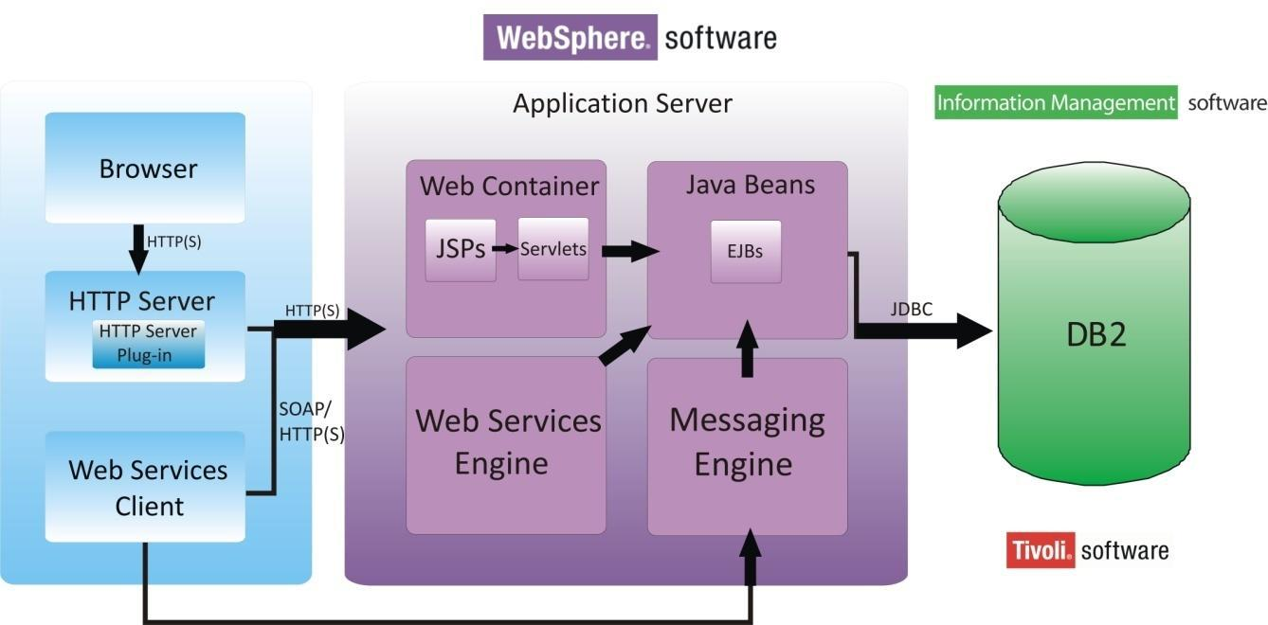

Fig 2.1: Product Perspective

**2.2 Software Interface**

**Client on Internet**

Web Browser, Operating System (any)

**Client on Intranet**

Web Browser, Operating System (any)

**Web Server**

WASCE, Operating System (any)

**Data Base Server**

DB2, Operating System (any)

**Development End**

RAD (J2EE, Java, Java Bean, Servlets, HTML, XML, AJAX), DB2, OS (Windows), WebSphere(Web Server)

**2.3 Hardware Interface**

**Minimum Requirements:**



**Client Side**

|  |  |  |  |  |  |  |  |  |  |
| --- | --- | --- | --- | --- | --- | --- | --- | --- | --- |
|  |  |  |  | **Processor** |  | **RAM** |  | **Disk Space** |  |
|  |  |  |  |  |  |  |  |  |  |
|  | Internet Explorer - 6 |  |  | Intel Pentium III or AMD - |  | 128 MB |  | 100 MB |  |
|  |  |  | 800 MHz |  |  |  |
|  |  |  |  |  |  |  |  |  |
|  |  |  |  |  |  |  |  |  |  |



*2009* *Page 8*

Virtual Medical Home

**Server Side**

|  |  |  |  |  |  |  |  |  |  |  |  |
| --- | --- | --- | --- | --- | --- | --- | --- | --- | --- | --- | --- |
|  |  |  |  |  | **Processor** |  | **RAM** |  | **Disk Space** |  |  |
|  |  |  |  |  |  |  |  |  |  |  |  |
|  |  | RAD |  |  |  |  | 1 GB | | 3.5 GB |  |  |
|  |  |  |  |  | Intel Pentium III or AMD - |  |  |  |  |  |  |
|  |  |  |  |  |  |  |  | 500 MB |  |  |
|  |  | DB2 - 9.5 |  |  | 800 MHz |  | 256 MB | | (Excluding Data |  |  |
|  |  |  |  |  |  |  |  |
|  |  |  |  |  |  |  |  |  | Size) |  |  |
|  |  |  |  |  |  |  |  |  |  |  |  |
|  |  | **Recommended Requirements:** | | | |  |  |  |  |  |  |
|  |  |  |  |  |  |  |  |  |  |  |  |
|  |  |  |  |  | **Client Side** |  |  |  |  |  |  |
|  |  |  |  |  |  |  |  |  |  |  |  |
|  |  |  |  |  | **Processor** |  | **RAM** |  | **Disk Space** |  |  |
|  |  |  |  |  |  |  |  |  |  |  |  |
|  |  | Internet Explorer - 6 |  |  | All Intel or AMD - 1 GHZ |  | 256 MB |  | 100 MB |  |  |
|  |  |  |  |  |  |  |  |  |  |  |  |
|  |  | Web cam |  |  | 5.0 Megapixel Camera | | | |  |  |  |
|  |  |  |  |  |  |  |  |  |  |  |  |
|  |  |  |  |  | **Server Side** |  |  |  |  |  |  |
|  |  |  |  |  |  |  |  |  |  |  |  |
|  |  |  |  |  | **Processor** |  | **RAM** |  | **Disk Space** |  |  |
|  |  |  |  |  |  |  |  |  |  |  |  |
|  |  | RAD |  |  |  |  | 2 GB |  | 3.5 GB |  |  |
|  |  |  |  |  |  |  |  |  |  |  |  |
|  |  |  |  |  | All Intel or AMD - 2 GHZ |  |  |  | 500 MB |  |  |
|  |  | DB2 - 9.5 |  |  |  | 512 MB |  | (Excluding Data |  |  |
|  |  |  |  |  |  |  |  |  |
|  |  |  |  |  |  |  |  |  | Size) |  |  |
|  |  |  |  |  |  |  |  |  |  |  |  |

**2.4 Communication Interface**

Client (customer) on Internet will be using HTTP/HTTPS protocol.

Client (system user) on Internet will be using HTTP/HTTPS protocol.

**2.5 Constraints**

GUI is only in English.

Login and password is used for the identification of users.

Only registered patients and doctors will be authorized to use the services.



*2009* *Page 9*

Virtual Medical Home

Limited to HTTP/HTTPS.

This system is working for single server.

**2.6 ER Diagram**

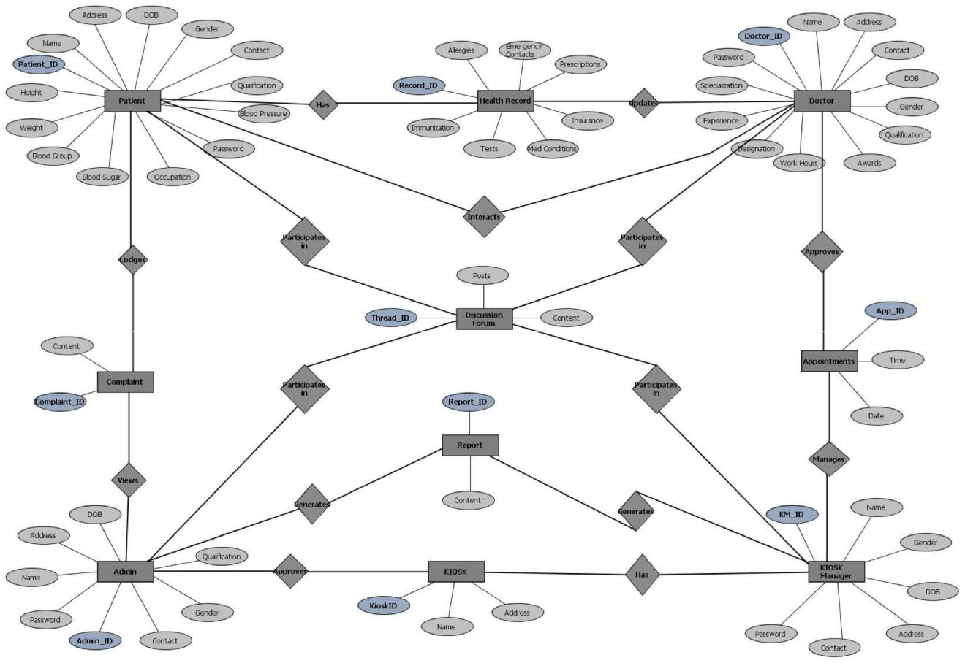

**2.7 Use Case Model Survey**



*2009* *Page 10*

Virtual Medical Home

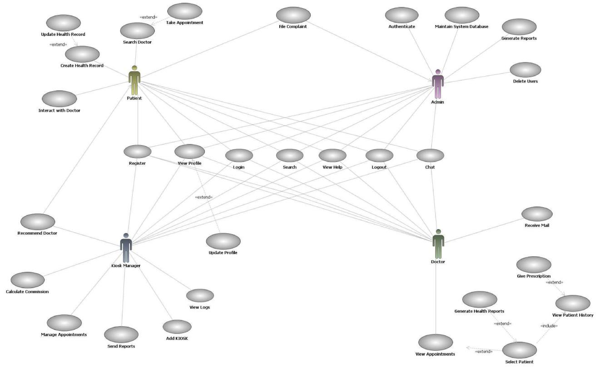

**Fig2.2: Use Case Model Survey**

**Patient:**

Patients can search for doctor and make online appointments. They also can view their health record, lab reports, doctor’s prescription and medical expenses. Patient can also register complaint on any doctor.

**Doctor:**

Doctor’s can give appointments, e-prescription and can update and view patient’s health record.

**Kiosk Manager:**

Kiosk Manager views and manages the appointments, performs day open and close activities and calculates his commission. He also sends reports to admin.

**Admin:**

Admin has the authority to add/delete users, grant permission to doctors and kiosk manager, to generate and view reports. He also views the complaints of patients and takes necessary actions.

**2.8 Architecture Diagram**



*2009* *Page 11*

Virtual Medical Home

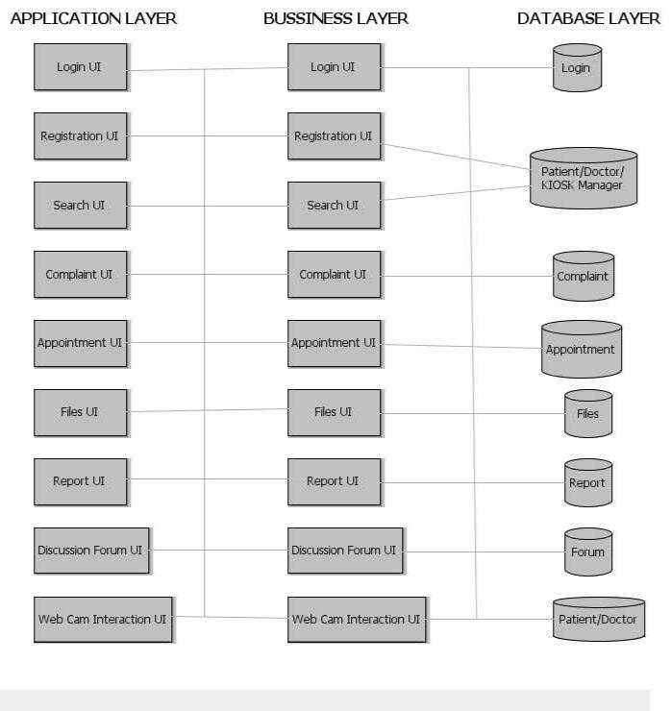

**Fig2.3: Architecture Diagram**

**2.9 Database Design**



*2009* *Page 12*

Virtual Medical Home

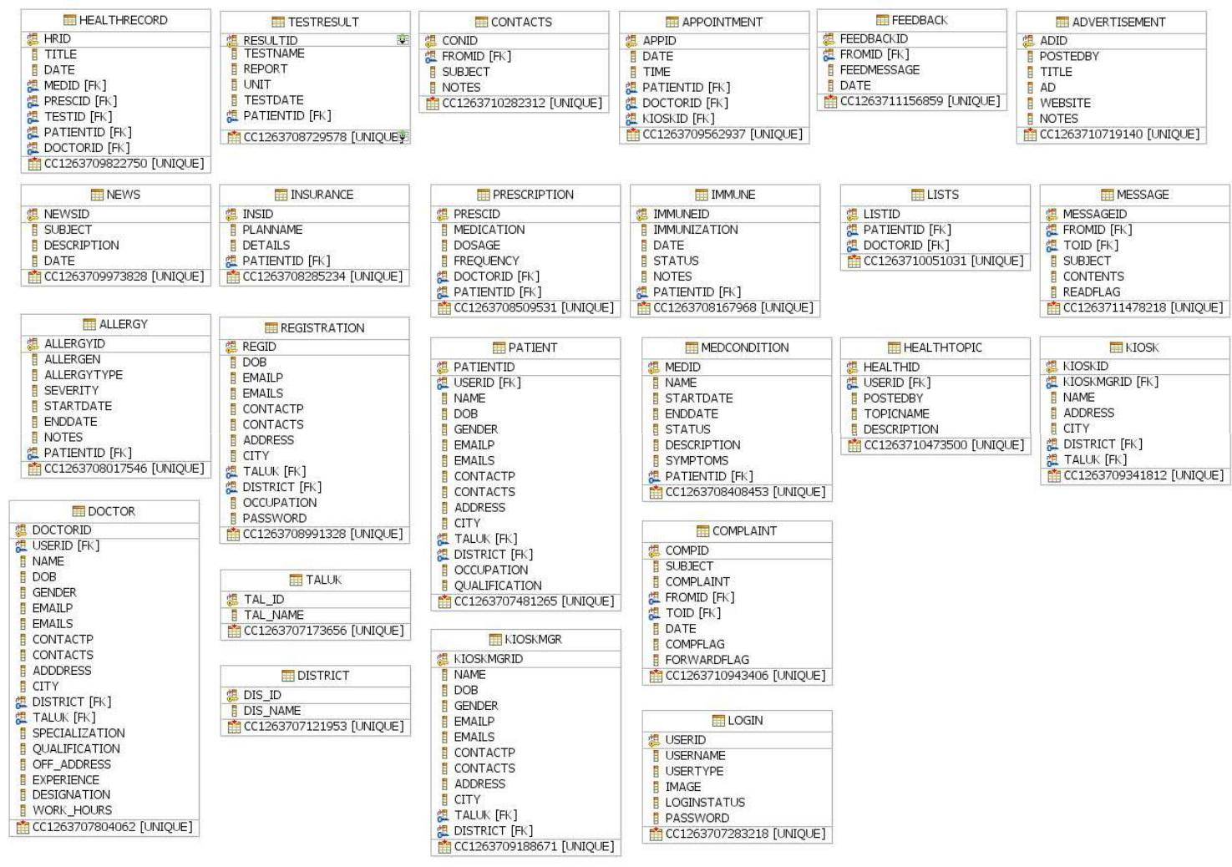

**Fig2.4:Database Design**

3.Specific Requirements

**3.1 Use Case Reports**

**3.1.1 Patient use-case report**



*2009* *Page 13*

Virtual Medical Home

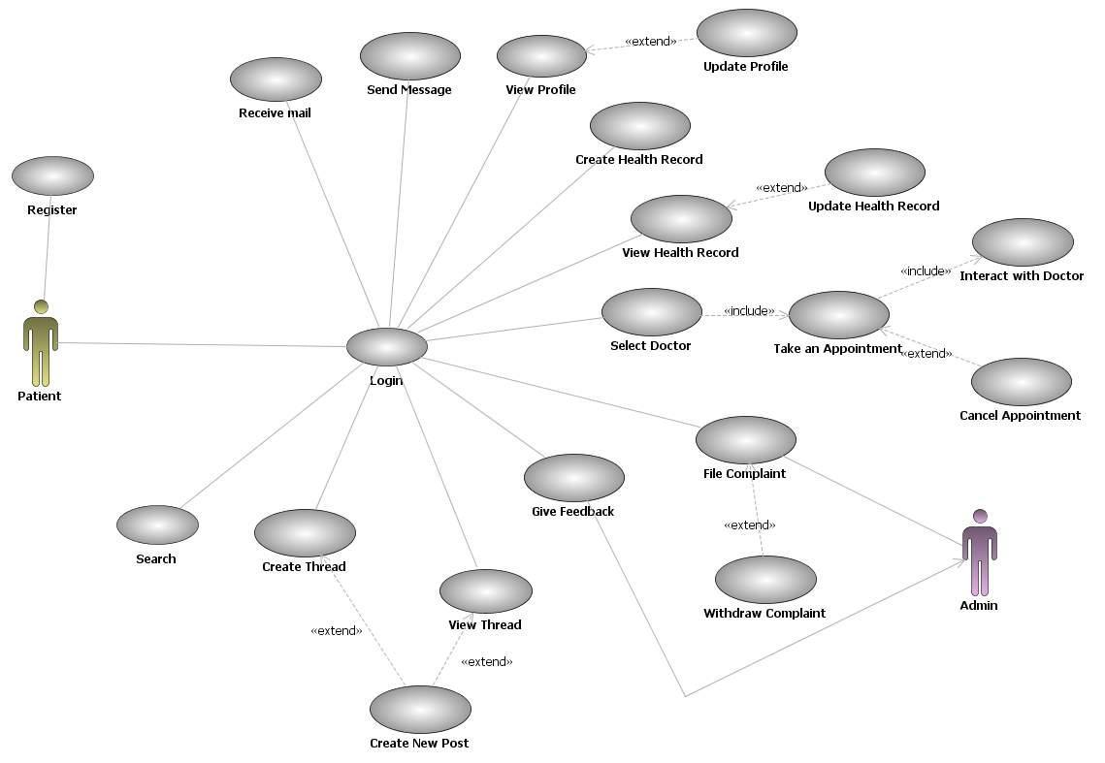

|  |  |  |  |
| --- | --- | --- | --- |
|  |  | Fig3.1: Use case diagram for patient |  |
|  |  |  |  |
|  | **USE CASE** | **DESCRIPTION** |  |
| **SignIn** | | The patient has to SignIn in order to . |  |
| **View profile** | | Every registered patient has his/her own profile containing personal details. |  |
| **Update profile** | | The patient has the option to update his/her own profile. |  |
| **Create health record** | | The patient can create his/her own health record. |  |
| **Update health record** | | The patient can update his/her health record. |  |
| **Select doctor** | | The patient can select doctor based on various criteria. |  |
| **Take an appointment** | | The patient can request for an appointment to a particular doctor. |  |
| **Interact with doctor** | | The patient can interact with doctor . |  |
| **File complaint** | | The patient can file complaint on doctor to admin. |  |
| **Withdraw complaint** | | The patient has option to withdraw his/her complaint . |  |
| **View thread** | | The patient can view already created thread in a discussion forum. |  |
| **Create thread** | | The patient can create a new thread in a discussion forum. |  |
| **Create new post** | | The patient can create a new post in a newly created or already present thread. |  |
| **Send Message** | | The patient can send private message to doctors and admin. |  |
| **Receive mail** | | The patient can receive mail. |  |
| **Search** | | The patient can search for a particular item in website by entering the keyword. |  |

**3.1.2 Doctor use-case report**



*2009* *Page 14*

Virtual Medical Home

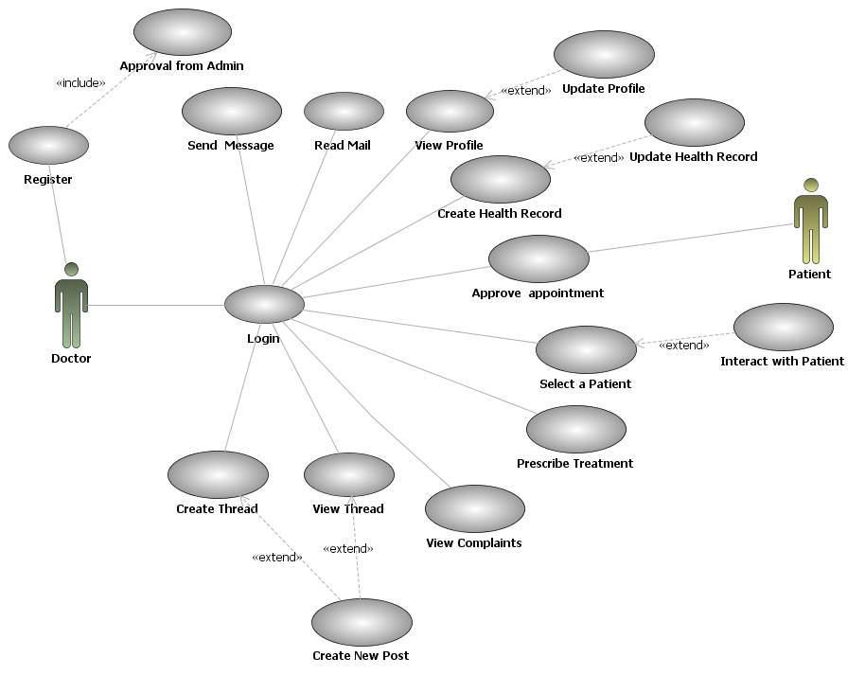

|  |  |  |  |
| --- | --- | --- | --- |
|  |  | Fig3.2: Use case diagram for Doctor |  |
|  |  |  |  |
|  | **USE CASE** | **DESCRIPTION** |  |
| **Sign in** | | The doctor has to Sign In in order to start begin his work. |  |
| **View profile** | | Every registered doctor has his/her own profile containing personal and professional de- |  |
|  |  | tails. |  |
| **Update profile** | | The doctor has the option to update his/her own profile. |  |
| **Create health record** | | The doctor can create health record of a patient. |  |
| **Update health** | | The doctor can make necessary changes to health record. |  |
| **record** | |  |  |
| **Acknowledge an ap-** | | The doctor accept/rejects the request of patient for an appointment. |  |
| **pointment** | |  |  |
| **Select a patient** | | The doctor selects a patient for further interaction. |  |
| **Prescribe treatment** | | The doctor prescribe the treatment for patient. |  |
| **View complaints** | | The doctor views the feedback of the admin to the complaints issued to a doctor. |  |
| **View thread** | | The doctor can view already created thread in a discussion forum. |  |
| **Create thread** | | The doctor can create a new thread in a discussion forum. |  |
| **Post thread** | | The doctor can post a new created or already present thread. |  |
| **Send message** | | The doctor can send private messages to patients and admin. |  |
| **Receive mail** | | The doctor can receive mail. |  |
| **Search** | | The doctor can search for a particular item in website by entering the keyword. |  |

**3.1.3 Kiosk Manager use-case report**



*2009* *Page 15*

Virtual Medical Home

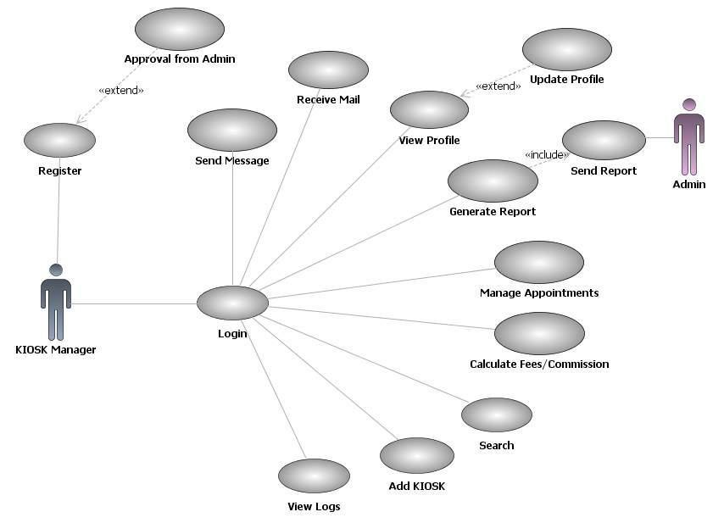

|  |  |  |  |  |
| --- | --- | --- | --- | --- |
|  |  |  | Fig3.3: Use case diagram for Kiosk Manager |  |
|  |  |  |  | |
|  | **USE CASE** |  | **DESCRIPTION** | |
| **Sign in** | |  | The Kiosk Manager has to Sign In in order to start begin his work. | |
| **View profile** | |  | Every registered KM has his/her own profile containing personal and professional details. | |
| **Update profile** | |  | The KM has the option to update his/her own profile. | |
| **Add Kiosk** | |  | The KM can add new Kiosk . | |
| **Manage appoint-** | |  | The KM can manage the appointments of doctors and patients . | |
| **ments** | |  |  |  |
| **Calculate fees** | |  | The KM can charge fees for patient for using the kiosk. | |
| **Views logs** | |  | The | |
| **Send report** | |  | The KM can send report to admin. | |
| **Approval from admin** | |  | The KM should get approval from the admin . | |
|  | |  |  | |
| **Send message** | |  | The KM can send private messages to patients and admin. | |
| **Receive mail** | |  | The KM can receive mail. | |
| **View thread** | |  | The KM can view already created thread in a discussion forum. | |
| **Create thread** | |  | The KM can create a new thread in a discussion forum. | |
| **Create new post** | |  | The KM can create a new post in a newly created or already present thread. | |
| **Search** | |  | The KM can search for a particular item in website by entering the keyword. | |

**3.1.4 Admin use-case report**



*2009* *Page 16*

Virtual Medical Home

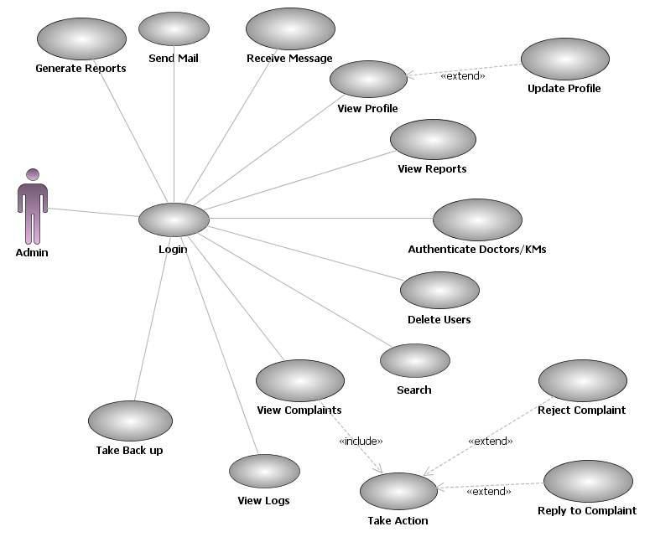

|  |  |  |  |  |
| --- | --- | --- | --- | --- |
|  |  |  | Fig3.4: Use case diagram for Admin |  |
|  |  |  |  |  |
|  | **USE CASE** |  | **DESCRIPTION** |  |
| **Sign in** | |  | The admin has to Sign In in order to start begin his work. |  |
| **View profile** | |  | Admin has his/her own profile containing personal and professional details. |  |
| **Update profile** | |  | The admin has the option to update his/her own profile. |  |
| **View reports** | |  | The admin can view reports sent by KM. |  |
| **Generate reports** | |  | The admin can generate reports. |  |
| **Authenticate doc-** | |  | The admin will authenticate doctors and KM. |  |
| **tor/KM** | |  |  |  |
| **View complaint** | |  | The admin views the complaint sent by other users. |  |
| **Take action** | |  | The admin can take necessary actions . |  |
| **Take backup** | |  | The admin can take backup of the system. |  |
| **Delete users** | |  | The admin is given the option to delete the users . |  |
| **Send mail** | |  | The admin can send mail. |  |
| **Receive message** | |  | The admin can receive private messages from patients, KMs and doctors. |  |
| **View thread** | |  | The admin can view already created thread in a discussion forum. |  |
| **Create thread** | |  | The admin can create a new thread in a discussion forum. |  |
| **Post thread** | |  | The admin can post a new created or already present thread. |  |
| **Search** | |  | The admin can search for a particular item in website by entering the keyword. |  |

**3.2 Activity Diagrams**

**3.2.1 User Registration Activity**



*2009* *Page 17*

Virtual Medical Home

Initially user is made to fill all mandatory fields filled in registration form. Once the user clicks sub-mit, the username is verified. If the username is already present, then the user is again taken back, so that he can change the username. If the username is not present then it checks for password and remaining mandatory fields. If any of the mandatory field is left empty or filled incorrect, then the user is informed to enter the correct values. Once all these verifications are succeeded, then the reg-istration is done.

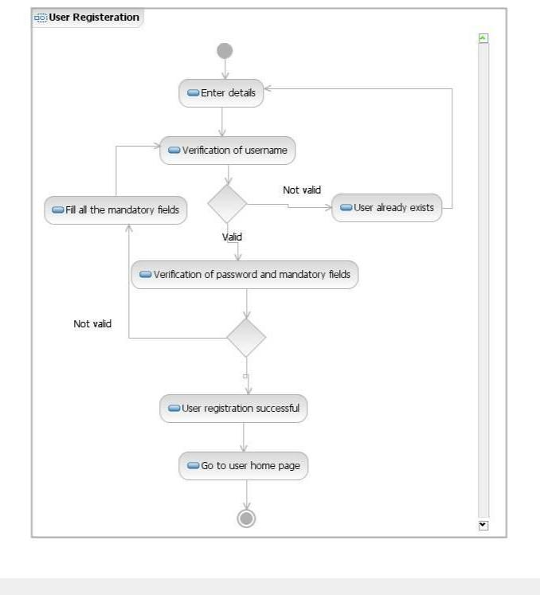

Fig 3.5: Activity Diagram Representing User Registration

**3.2.2 Doctor and Kiosk Manager Registration Activity**

The doctor and KM needs to fill all mandatory fields filled in registration form. Once they click sub-mit, the username is verified. If the username is already present, then they are again taken back, so that they can change the username. If the username is not present then it checks for password and



*2009* *Page 18*

Virtual Medical Home

remaining mandatory fields. If any of the mandatory field is left empty or filled incorrect, then they are informed to enter the correct values. These details are sent to admin for verification and the admin verifies the data and approves registration and grants privileges.

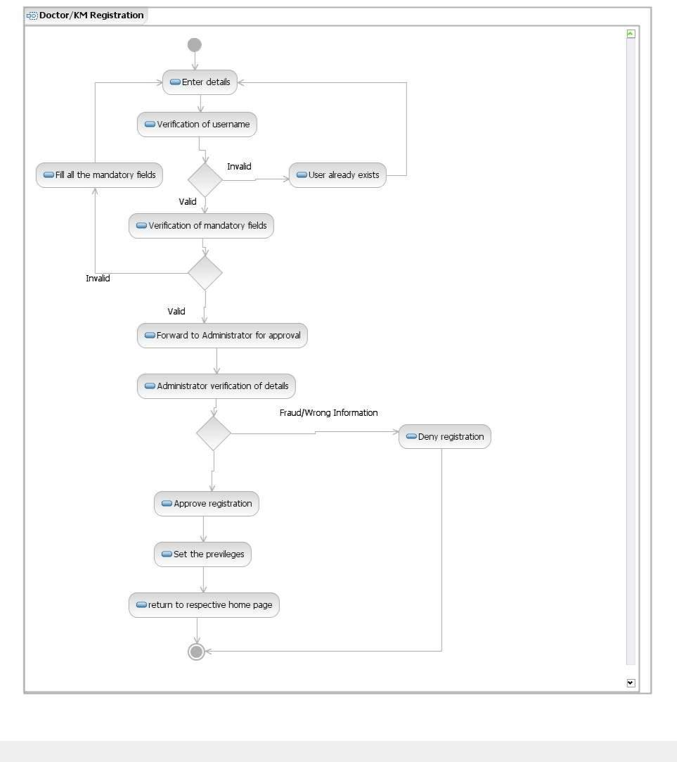

Fig 3.6: Activity Diagram Representing Doctor and KM Registration

**3.2.3 User Login Activity**

User is made to enter the username and password, if he is signing in through KIOSK, KIOSK ID has to be en-tered, then entered values are verified. If it is a valid username and password, then the user is logged in, or else they are asked to re enter the correct values.



*2009* *Page 19*

Virtual Medical Home

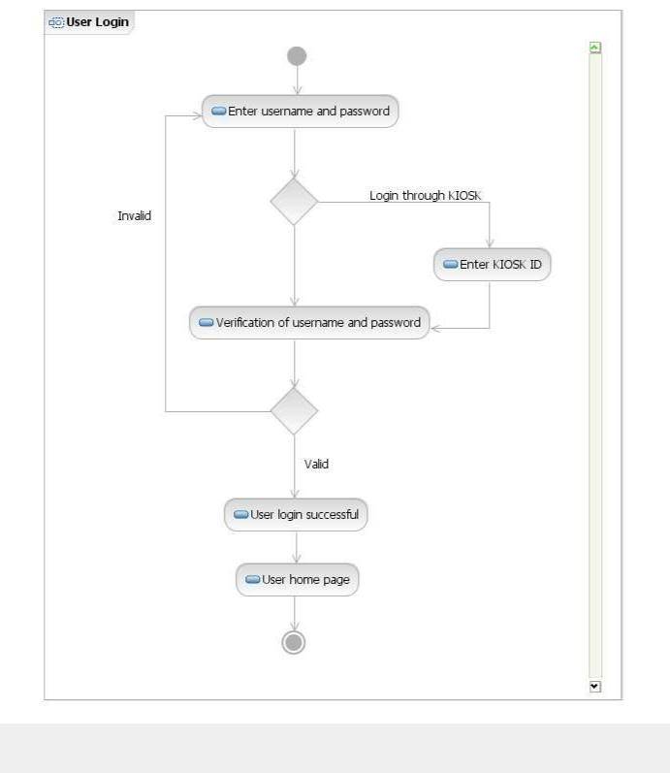

Fig 3.7: Activity Diagram Representing User Login

**3.2.4 Privileged User Login Activity**

Privileged User such as Doctor, Kiosk Manager and Administrator is made to enter the username and pass-word, entered values are verified. If it is a valid username and password, then the user is logged in and as-signed the respective privileges, or else they is asked to retry by entering the correct values.



*2009* *Page 20*

Virtual Medical Home

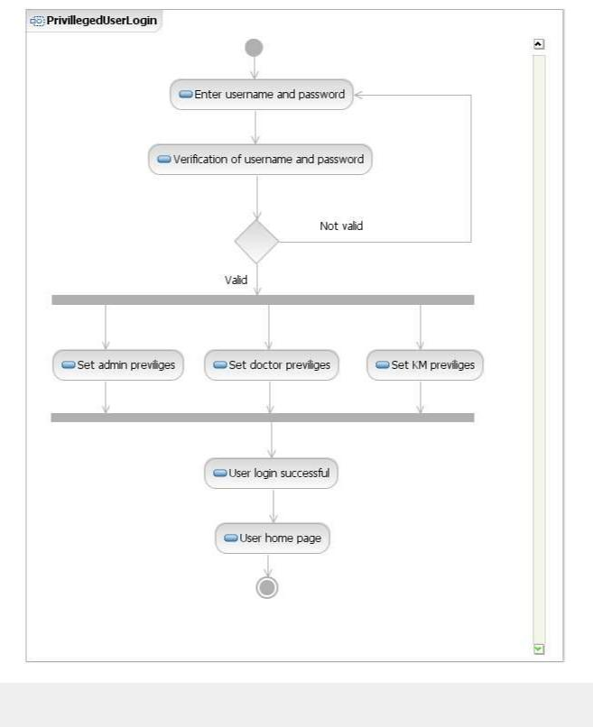

Fig 3.8: Activity Diagram Representing Privileged User Login

**3.2.5 Take Appointment Activity**

The patient will search for a doctor using search option. Then the patient selects a doctor from search results

and enters date and time for an appointment and sends it to the doctor. Doctor views this request.



*2009* *Page 21*

Virtual Medical Home

Then he can either reject the request or can approve it by sending an appropriate message to pa-tient.

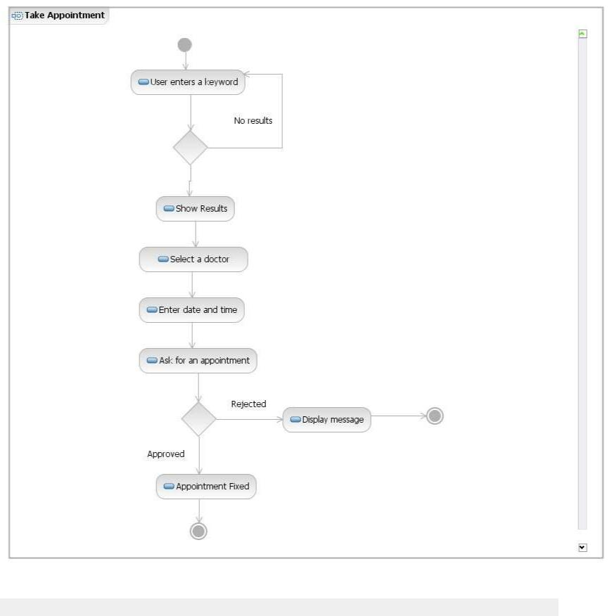

Fig 3.9: Activity Diagram For Taking Appointment

**3.2.6 Web Camera Interaction Activity**

The patient will select a doctor and then if he has an appointment with that doctor, he can directly start

web cam interaction session. If the patient does not have appointment, then he should check whether

the doctor is busy or available. If the doctor is available, the patient will send a request to doctor.



*2009* *Page 22*

Virtual Medical Home

If the doctor accepts the request, the patient can start the interaction session. Finally, patient will close

the session.

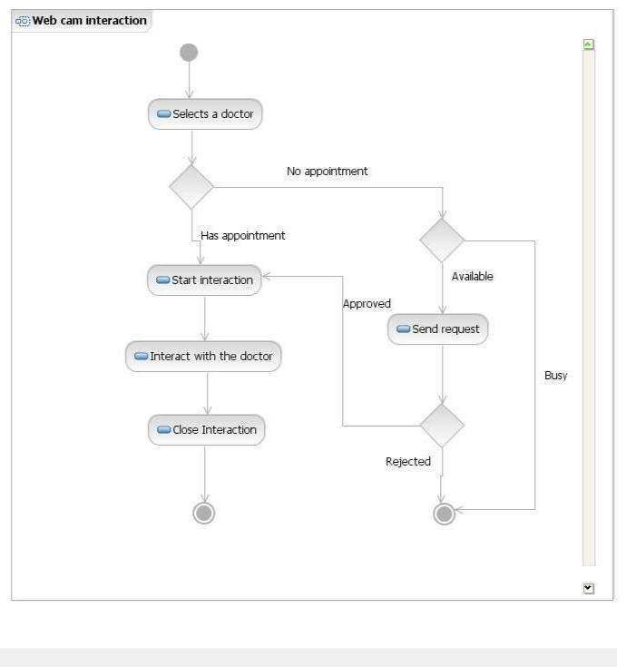

Fig3.10 : Activity Diagram Representing Web Cam Interaction

**3.2.7 Providing Prescription Activity**

The doctor selects a particular patient, then views his/her health record to analyze his/her condi-tions,

symptoms of diseases etc.. And then doctor enters the prescription and send it to the patient.



*2009* *Page 23*

Virtual Medical Home

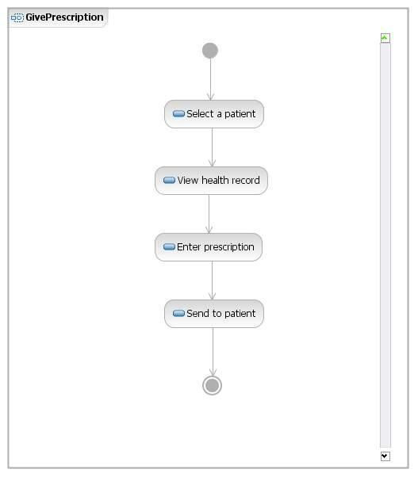

Fig3.11 : Activity Diagram For Giving Prescription

**3.2.8 Lodging a Complaint Activity**

The patient enters the complaint text and sends it to admin and the system generated Complaint_ID is returned to user.



*2009* *Page 24*

Virtual Medical Home

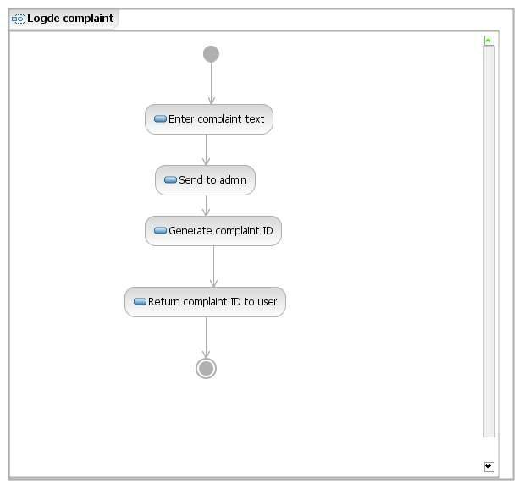

Fig 3.12: Activity Diagram For Lodging Complaint

**3.2.9 Replying a Complaint Activity**

The admin views the complaint and then he may reply to the user or he may select the respective doctor and forwards the complaint to him.



*2009* *Page 25*

Virtual Medical Home

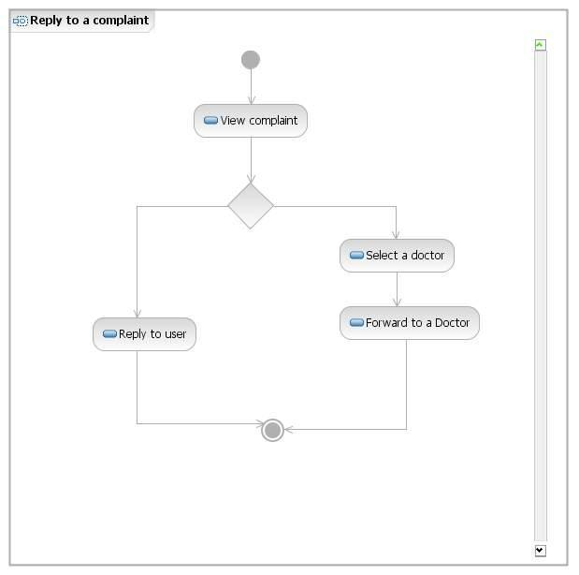

Fig 3.13: Activity Diagram For Representing Reply To Complaint

**3.2.10 Participating in a Discussion Forum Activity**

The system displays all the posts to the users. The user can select a thread from the recent posts and can reply for that post or he/she can create the new post. The user can directly create a new thread and in that he/she can create a new post. The user can also search for a particular topic and can se-lect a thread from the results and can create a new post.



*2009* *Page 26*

Virtual Medical Home

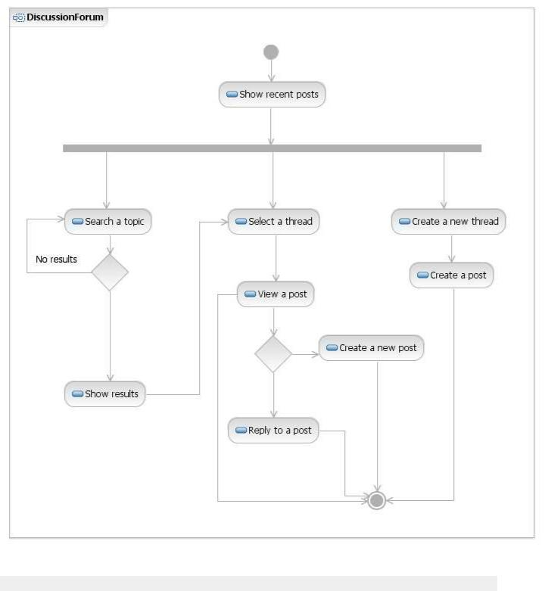

Fig 3.14: Activity Diagram Representing Discussion Forum

**3.3 Sequence Diagrams**

**3.3.1 Users Login Sequence Diagram**



*2009* *Page 27*

Virtual Medical Home

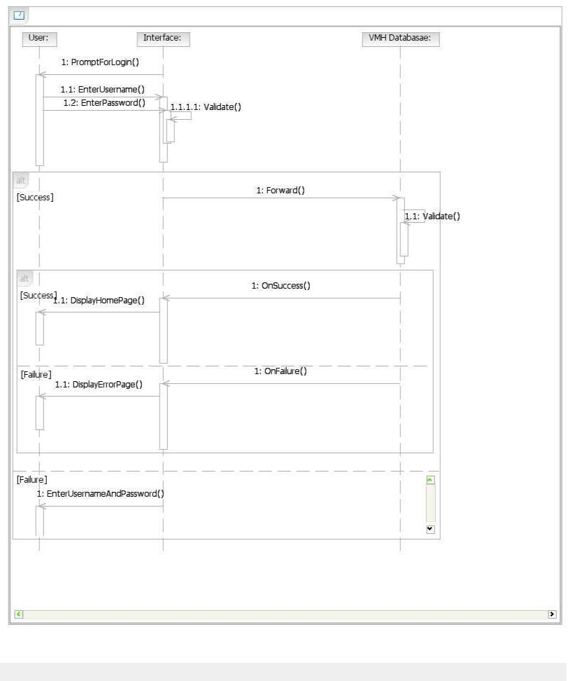

Fig 3.15: Sequence Diagram Representing Login Process

**3.3.2 Make an Appointment Sequence Diagram**



*2009* *Page 28*

Virtual Medical Home

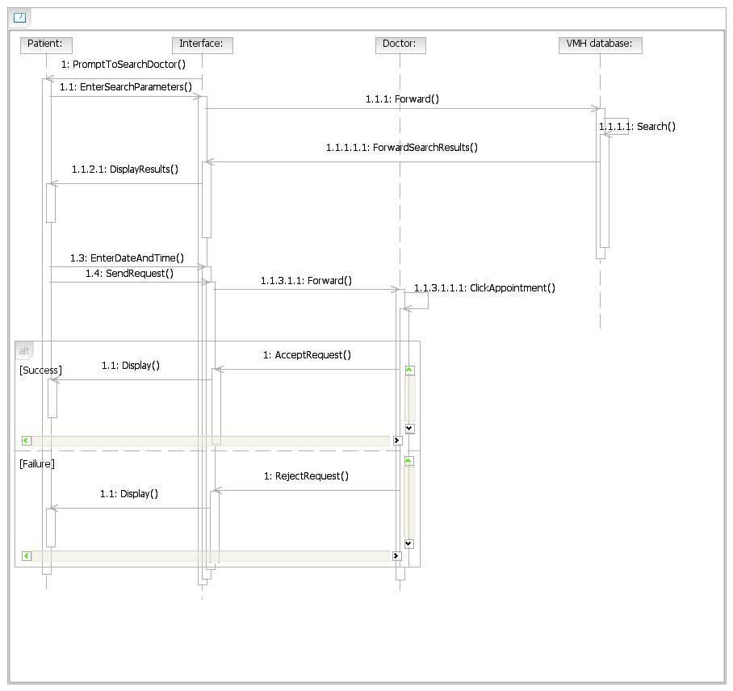

Fig3.16:Sequence Diagram Representing Appointment

**3.3.3 Lodge Complaint Sequence Diagram**



*2009* *Page 29*

Virtual Medical Home

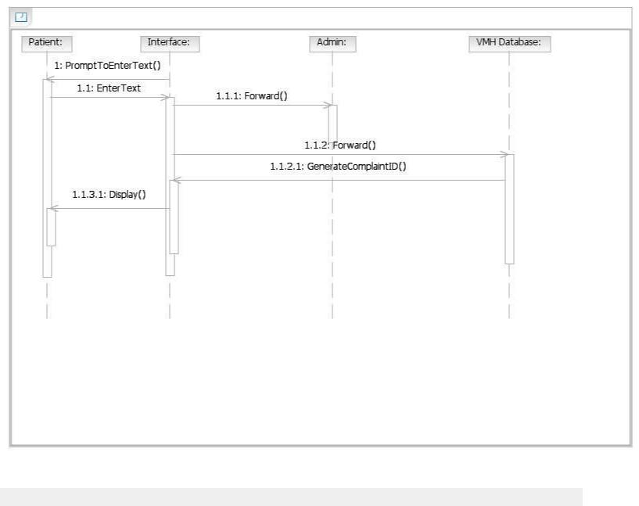

Fig3.17:Sequence Diagram for Lodging Complaint

**3.3.4 Prescription Sequence Diagram**



*2009* *Page 30*

Virtual Medical Home

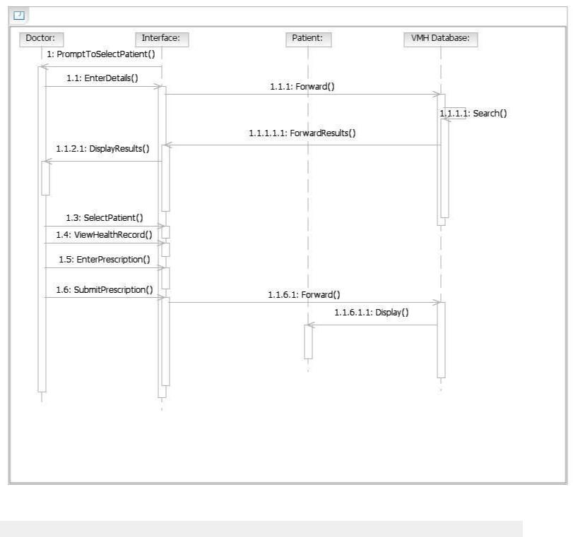

Fig3.18:Sequence Diagram for Prescription

**3.3.5 Authentication of Privileged Users Sequence Diagram**



*2009* *Page 31*

Virtual Medical Home

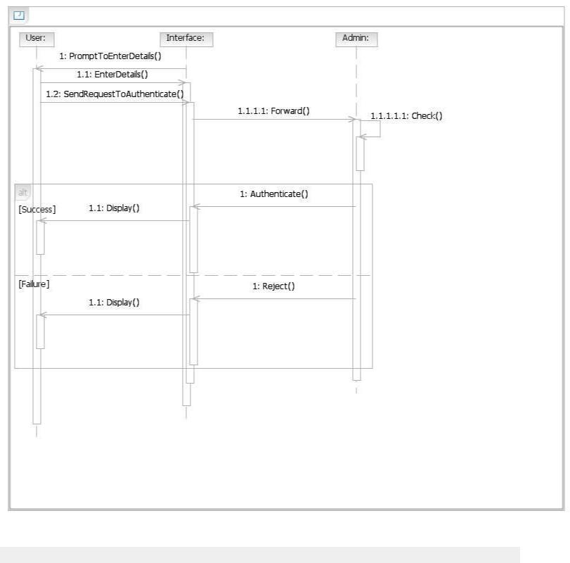

Fig3.19:Sequence Diagram for Authentication of Privileged Users

**3.3.6 Web Cam Interaction**



*2009* *Page 32*

Virtual Medical Home

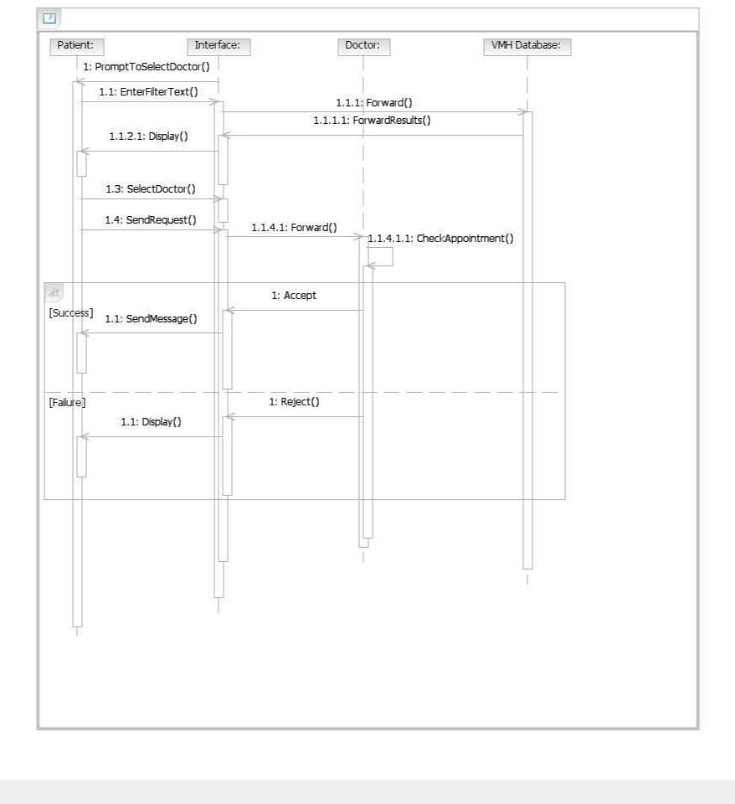

Fig3.20:Sequence Diagram Representing Web Cam Interaction

**4. Supporting Information**



*2009* *Page 33*

Virtual Medical Home

**4.1 Index**



*2009* *Page 34*

Virtual Medical Home

A

Abbreviations · 5

Acronyms · 5

Administrator · 16

AJAX · 7, 13

Analysis · 3 Design · 18

C

Client on Internet · 8 Client on Intranet · 8 Communication · 11 Complaints · 5 Constraints · 11 Construction · 4

D

Data Base · 15

DB2 · 5, 6

Definitions · 5

Development End · 8

Drawbacks · 8

Doctor · 4,13

E

Elaboration · 4

ER Diagram · 12

Existing System · 8

HTTPS · 8

I

Inception · 3

Interface · 9,10,11

Introduction · 4

J

J2EE · 5, 13

Java · 6

JSP · 5,6

K

Kiosk Manager· 4

KM· 5, 13

M

Medical Expenses · 3

Methodology · 4

O

Operating System · 6, 8

Our Plan· 8

Overall · 9

Overview · 8

Proposed System · 8

Purpose · 4

R

RAD · 6

References · 7

Reports · 4

Rational Unified Process · 3

S

Scope · 4

Sequence · 30

Software · 9

T

Transition· 4

Technologies · 7

U

Use-case · 13, 16

UML · 5

V

Virtual Medical Home· 4

VMH · 4, 5

H

Hardware · 10

Health Record · 10

HTML · 8

HTTP · 5,8

P W

Patient · 4, 13 WASCE · 5, 6

Precription · 4

Product Perspective · 9



*2009* *Page 35*

Virtual Medical Home

**Special Thanks**

We convey a special thanks to our department and to our college. We also convey a special thanks to all these software’s and websites, they have been helping a lot in doing the project.



*2009* *Page 36*